Attachments
Attachment 1.
Blueprint of Work-Life Balance Scale
No. | Aspects | Number of Item |  | Amount
No. | Aspects | Favorable | Unfavorable | Amount
1 | Work Interference with Personal Life | 1,9,13,21 | 3,8,11,12,15,17,  18,19,22,23,24 | 15
2 | Personal Life Interference with Work | - | 2,4,5,7,16 | 5
3 | Personal Life/Work Enhancement | 6,10 | - | 2
Total Item |  |  |  | 22

Attachment 2
Blueprint of Perceived Long Working Hours Scale
No. | Aspects | Number of Item |  | Amount
No. | Aspects | Favorable | Unfavorable | Amount
1 | Structural | 2 | 1 | 2
2 | Cyclical | 4 | 3 | 2
3 | Frictional | 5,6 | - | 2
4 | Overall | 7,8 |  | 2
Total Item |  |  |  | 8

No. | Karakteristik | Number of Item |  | Amount
No. | Karakteristik | Favorable | Unfavorable | Amount
1 | Anggota tim dapat mengungkapkan pikiran dengan bebas | 2 | 1 | 2
2 | Tim mendorong dan mengizinkan pengambilan risiko | 4 | 3 | 2
3 | Anggota percaya dan hormat satu sama lain | 6,7 | 5 | 3
 | Total Item |  |  | 7
Attachment 3
Blueprint of Psychological Safety Scale

Attachment 4
Work-Life Balance Scale
No | Statement | Choices
No | Statement | 1 | 2 | 3 | 4 | 5
1 | I strive to be able to balance work life and responsibilities outside of work
2 | My personal life drains me of the energy I need for work
3 | I feel overwhelmed trying to balance work and personal life
4 | My work is being neglected because of everything that's going on in my personal life
5 | I don't focus at work because I'm too tired to take care of my personal life
6 | My job gives me the energy to do important activities outside of work
7 | I have difficulty completing my work because I am busy with personal matters
8 | I can't relax at home because I'm still busy with work
9 | I like the amount of time I can spend doing activities outside of work
10 | I'm in a better mood when I'm home because of my work
11 | I often find it difficult to choose between work and personal life
12 | I have to postpone personal interests because of work
13 | I can achieve what I want both in my personal life and work
14 | I often neglect personal needs because of work demands
15 | When I'm at work, I worry about the things I have to do outside of work
16 | I'm having a hard time making time for vacation due to the ensuing workload.
17 | My personal life is neglected because of my work
18 | I have to miss important personal activities because I spend time doing work
19 | I feel I have allocated appropriate time between activities in my personal life and work
20 | I sacrificed my personal life to get work done
21 | I'm too tired to do the things I want to do after work
22 | My job makes it difficult for me to manage the personal life I want
1 = never 2=rarely 3=seldom 4= often 5=really often

Attachment 5
Perceived Long Working Hours Scale
No. | Statement | Choices
No. | Statement | 1 | 2 | 3 |  | 4 |  | 5 |  | 6 | 7
1 | I feel uncomfortable when I turn off my device (computer/ laptop/ tablet/ iPad/ cellphone), to finish work after normal working hours.
2 | I consider working outside working hours to be normal.
3 | It's hard for me to avoid overtime in this situation.
4 | Need to work longer hours than usual to be able to complete my work.
5 | It is important for me to work longer hours than usual.
6 | I am required to work more than expected.
7 | I am aware that I continue to work after the regular working hours are over.
8 | Overall, I work longer hours than usual.
1 for Strongly Disagree – 7 for Strongly Agree

Attachment 6
Psychological Safety Scale
No. | Statement | Choices
No. | Statement | 1 | 2 | 3 |  | 4 |  | 5 |  | 6 | 7
1 | When you do wrong in this team, they will run against you.
2 | Team members can discuss complex issues.
3 | Team members reject people perceived as different.
4 | It's safe to take risks on this team.
5 | It's hard to ask for help to members in this team..
6 | No one on this team will intentionally act to belittle my efforts.
7 | My unique abilities and talents are valued and useful when working with this team.
1 for Strongly Disagree – 7 for Strongly Agree

Attachment 7
Brief Informed Consent
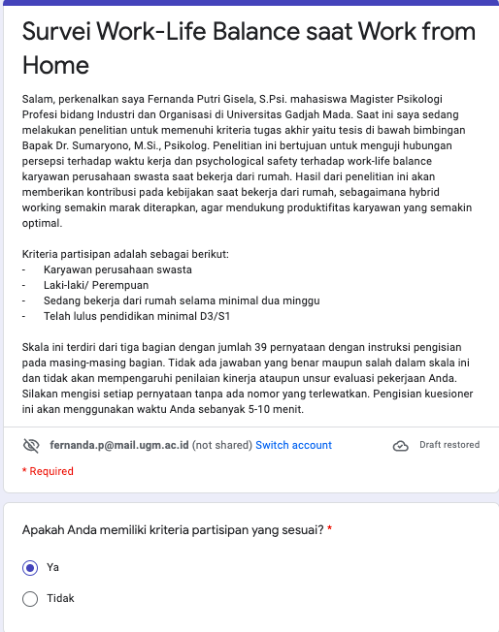

Attachment 8
Informed Consent
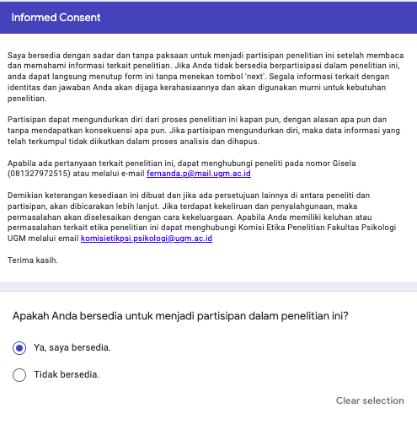

Attachment 9
Normality One-Sample Kolmogorov-Smirnov Test Result
One-Sample Kolmogorov-Smirnov Test
 |  | Perceived Working Hours | Psychological Safety | Work-Life Balance
N |  | 259 | 259 | 259
Normal Parameters^{a,b} | Mean | 29.82 | 35.41 | 78.33
Normal Parameters^{a,b} | Std. Deviation | 10.308 | 5.716 | 17.465
Most Extreme Differences | Absolute | .062 | .070 | .068
Most Extreme Differences | Positive | .062 | .055 | .064
Most Extreme Differences | Negative | -.051 | -.070 | -.068
Kolmogorov-Smirnov Z |  | 1.000 | 1.130 | 1.102
Asymp. Sig. (2-tailed) |  | .270 | .156 | .176
a. Test distribution is Normal.
b. Calculated from data.

Attachment10
Normality Test with Histogram Result
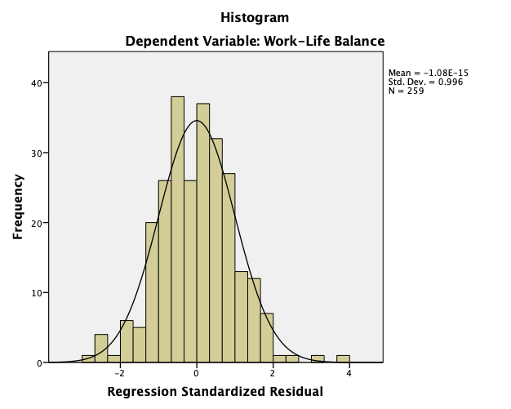

Attachment 11
Multicollinearity Test Result
Coefficientsª
Model |  | Unstandardized Coefficients |  | Standardized Coefficients | t | Sig. | Collinearity Statistics
 |  | B | Std. Error | Beta | t | Sig. | Tolerance | VIF
1 | (Constant) | 101.911 | 4.457 |  | 22.864 | .000
1 | Perceived Long Working Hours | -1.364 | .073 | -.805 | -18.601 | .000 | .872 | 1.147
1 | Psychological Safety | .483 | .132 | .158 | 3.650 | .000 | .872 | 1.147
a. Dependent Variable: Work-Life Balance

Attachment12
Heteroscedasticity with Scatter Plots Result

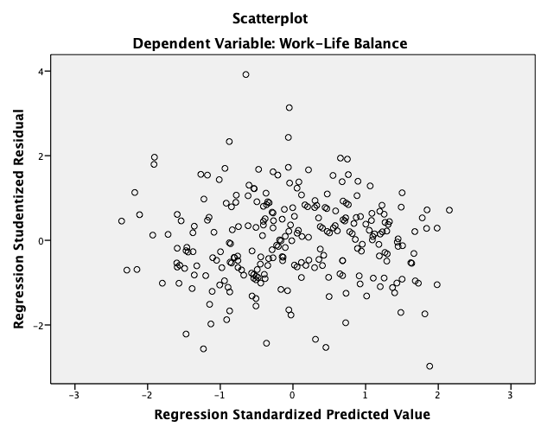

Attachment 13
Linearity with P-Plot Result
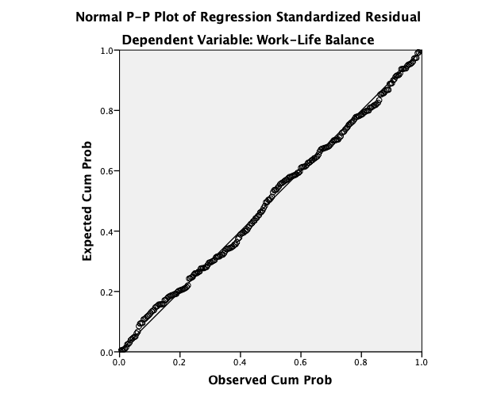

Attachment 14
Descriptive Analysis Test
Descriptive Statistics
 | N | Minimum | Maximum | Mean | Std. Deviation
Work-Life Balance | 258 | 33 | 115 | 78.40 | 17.465
Perceived Long Working Hours | 258 | 9 | 52 | 29.79 | 10.321
Psychological Safety | 258 | 15 | 49 | 35.40 | 5.725
Valid N (listwise) | 258

Attachment 15
Multiple Linear Regression Hypothesis Test Results (Model Summary)
Model Summary^{b}
Model | R | R Square | Adjusted R Square | Std. Error of the Estimate
1 | .763ª | .582 | .579 | 11.336
a. Predictors: (Constant), Psychological Safety, Perceived Long Working Hours
b. Dependent Variable: Work-Life Balance

Attachment 16
Hypothesis Test Results Zero-order Partial Correlation Perceived long working hours (Model Summary)
Model Summary
Model | R | R Square | Adjusted R Square | Std. Error of the Estimate
1 | .748ª | .560 | .558 | 11.605
2 | .763^{b} | .582 | .579 | 11.336
a. Predictors: (Constant), Perceived Long Working Hours
b. Predictors: (Constant), Perceived Long Working Hours, Psychological Safety

Attachment 17
Zero-order Partial Correlation Psychological Safety Hypothesis Test Results (Model Summary)
Model Summary
Model | R | R Square | Adjusted R Square | Std. Error of the Estimate
1 | .130ª | .017 | .013 | 17.350
2 | .763^{b} | .582 | .579 | 11.336
a. Predictors: (Constant), Psychological Safety
b. Predictors: (Constant), Psychological Safety, Perceived Working Hours

ANOVAª
Model |  | Sum of Squares | df | Mean Square | F | Sig.
1 | Regression | 45795.486 | 2 | 22897.743 | 178.173 | .000^{b}
1 | Residual | 32899.619 | 256 | 128.514
1 | Total | 78695.104 | 258
a. Dependent Variable: Work-Life Balance
b. Predictors: (Constant), Psychological Safety, Perceived Long Working Hours
Attachment 18
Multiple Linear Regression Hypothesis Test Results (ANOVA)

Attachment 19
Multiple Linear Regression Hypothesis Test Results (Coefficients)
Coefficientsª
Model |  | Unstandardized Coefficients |  | Standardized Coefficients | t | Sig.
 |  | B | Std. Error | Beta | t | Sig.
1 | (Constant) | 101.911 | 4.457 |  | 22.864 | .000
1 | Perceived Working Hours | -1.364 | .073 | -.805 | -18.601 | .000
1 | Psychological Safety | .483 | .132 | .158 | 3.650 | .000
a. Dependent Variable: Work-Life Balance
Attachment 20
Results of Descriptive Analysis of Position and Type of Work
Type of Work
 |  | Frequency | Percent | Valid Percent | Cumulative Percent
Valid | Engineer Lead/ Supervisor | 16 | 6.2 | 6.2 | 6.2
Valid | Engineer Staff | 38 | 14.7 | 14.7 | 20.8
Valid | HR/ Talent Acquisition | 30 | 11.6 | 11.6 | 32.4
Valid | HR Lead/ Supervisor | 8 | 3.1 | 3.1 | 35.5
Valid | Analyst Staff | 18 | 6.9 | 6.9 | 42.5
Valid | Accounting Staff | 20 | 7.7 | 7.7 | 50.2
Valid | Consultant Associate | 17 | 6.6 | 6.6 | 56.8
Valid | Product Researcher | 14 | 5.4 | 5.4 | 62.2
Valid | Analyst Head | 1 | .4 | .4 | 62.5
Valid | Operational Manager | 9 | 3.5 | 3.5 | 66.0
Valid | Marketing Staff | 25 | 9.7 | 9.7 | 75.7
Valid | HSE Staff | 1 | .4 | .4 | 76.1
Valid | Client Support Manager | 8 | 3.1 | 3.1 | 79.2
Valid | Admin Staff | 11 | 4.2 | 4.2 | 83.4
Valid | Designer | 7 | 2.7 | 2.7 | 86.1
Valid | Accounting Manager | 6 | 2.3 | 2.3 | 88.4
Valid | Management Trainee | 2 | .8 | .8 | 89.2
Valid | Quality Assurance Staff | 4 | 1.5 | 1.5 | 90.7
Valid | Full Stack Developer Staff | 4 | 1.5 | 1.5 | 92.3
Valid | Hostinger Abuse Specialist | 1 | .4 | .4 | 92.7
Valid | Legal Officer | 2 | .8 | .8 | 93.4
Valid | UX Researcher | 2 | .8 | .8 | 94.2
Valid | Project Manager | 7 | 2.7 | 2.7 | 96.9
Valid | Tender Staff | 2 | .8 | .8 | 97.7
Valid | Content Writer/ Copywriter | 4 | 1.5 | 1.5 | 99.2
Valid | Junior Art Director | 1 | .4 | .4 | 99.6
Valid | Risk Management Staff | 1 | .4 | .4 | 100.0
Valid | Total | 259 | 100.0 | 100.0

Attachment 21
Results of Descriptive Analysis of Marital Status
Marital Status
 |  | Frequency | Percent | Valid Percent | Cumulative Percent
Valid | Married | 50 | 19.4 | 19.4 | 19.4
Valid | Not Married | 209 | 80.6 | 80.6 | 100.0
Valid | Total | 259 | 100.0 | 100.0

Attachment 22
Results of Age Descriptive Analysis
Age
 |  | Frequency | Percent | Valid Percent | Cumulative Percent
Valid | 20 | 1 | .4 | .4 | .4
Valid | 21 | 3 | 1.2 | 1.2 | 1.6
Valid | 22 | 21 | 8.1 | 8.1 | 9.7
Valid | 23 | 47 | 17.8 | 17.8 | 27.5
Valid | 24 | 56 | 21.7 | 21.7 | 49.2
Valid | 25 | 24 | 9.3 | 9.3 | 58.5
Valid | 26 | 23 | 8.9 | 8.9 | 67.4
Valid | 27 | 15 | 5.8 | 5.8 | 73.3
Valid | 28 | 20 | 7.8 | 7.8 | 81.0
Valid | 29 | 9 | 3.5 | 3.5 | 84.5
Valid | 30 | 7 | 2.7 | 2.7 | 87.2
Valid | 31 | 6 | 2.3 | 2.3 | 89.5
Valid | 32 | 8 | 3.1 | 3.1 | 92.6
Valid | 33 | 6 | 2.3 | 2.3 | 95.0
Valid | 34 | 3 | 1.2 | 1.2 | 96.1
Valid | 36 | 1 | .4 | .4 | 96.5
Valid | 37 | 3 | 1.2 | 1.2 | 97.7
Valid | 38 | 1 | .4 | .4 | 98.1
Valid | 39 | 1 | .4 | .4 | 98.4
Valid | 42 | 1 | .4 | .4 | 98.8
Valid | 44 | 1 | .4 | .4 | 99.2
Valid | 46 | 1 | .4 | .4 | 99.6
Valid | 53 | 1 | .4 | .4 | 100.0
Valid | Total | 259 | 100.0 | 100.0

Attachment 23
Ethical Clearance

