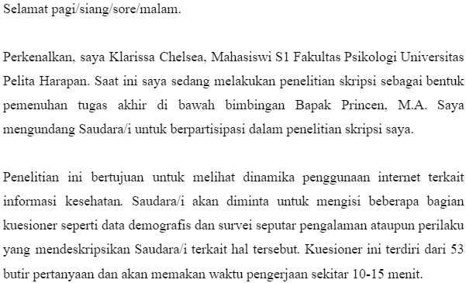
LAMPIRAN A - KUESIONER PENELITIAN DATA FIELD
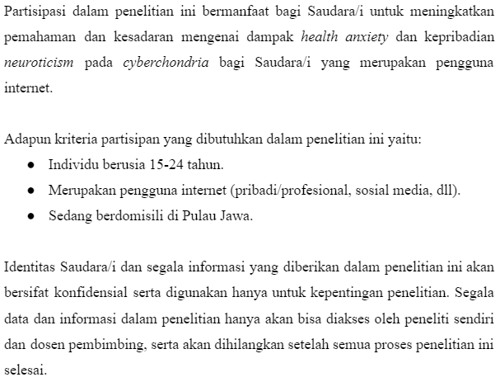
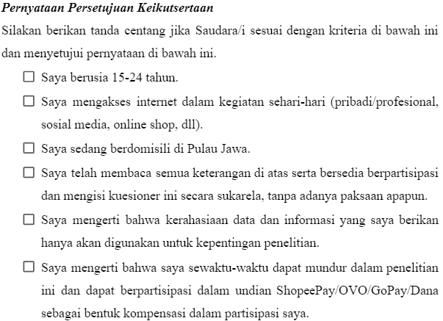
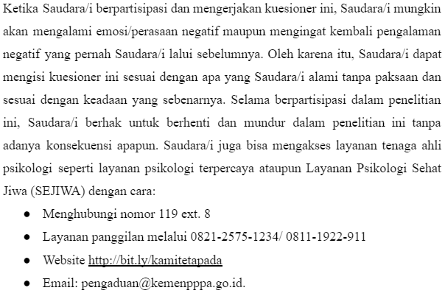
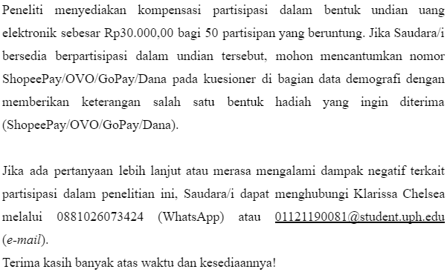
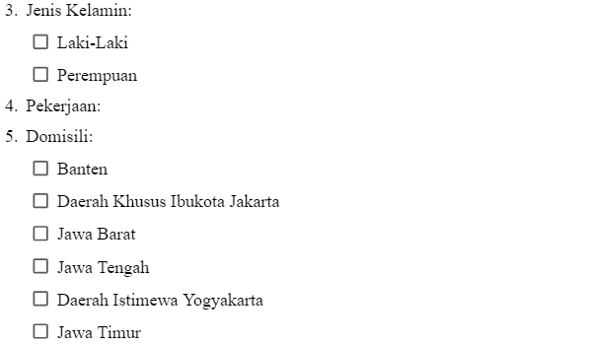
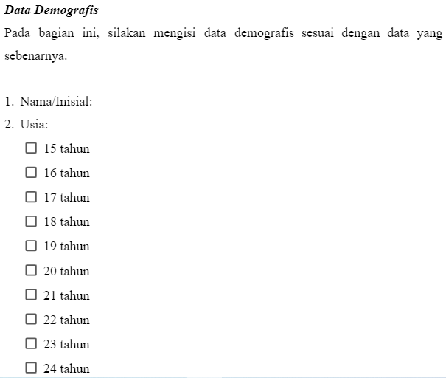
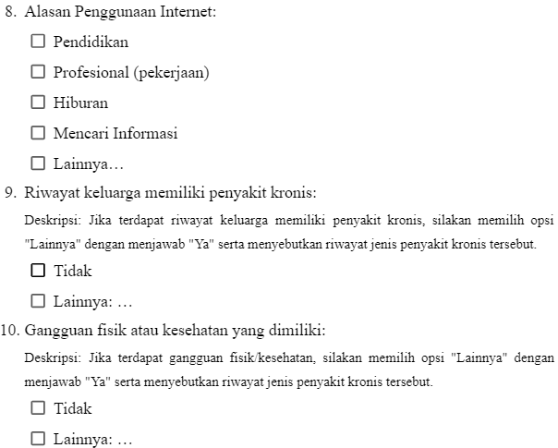
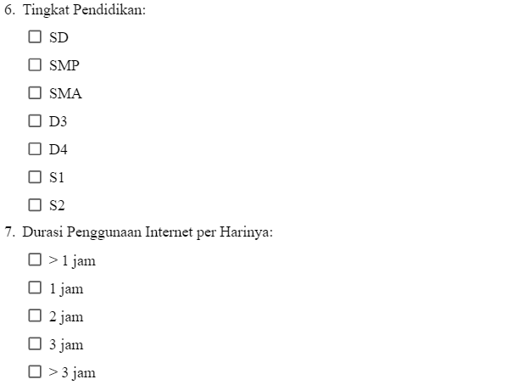

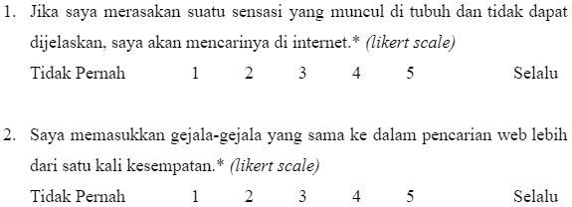
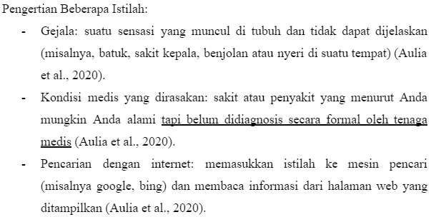
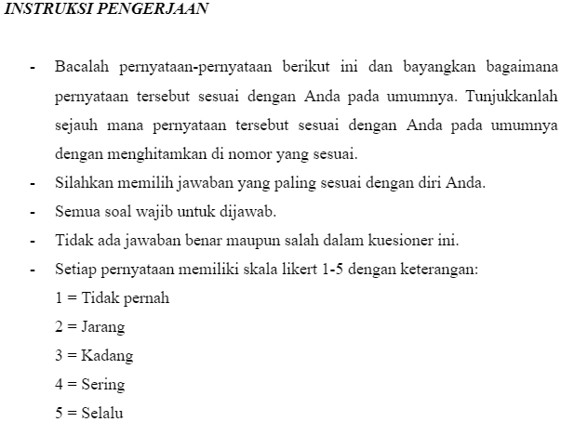
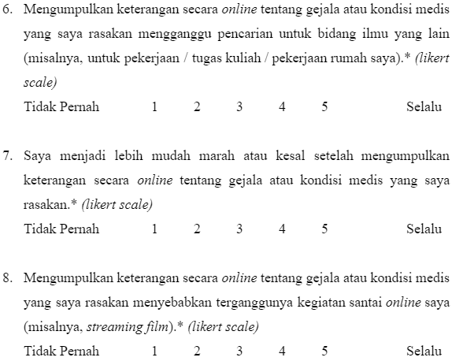
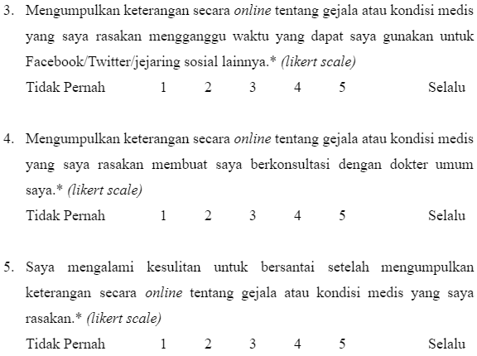
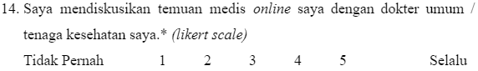
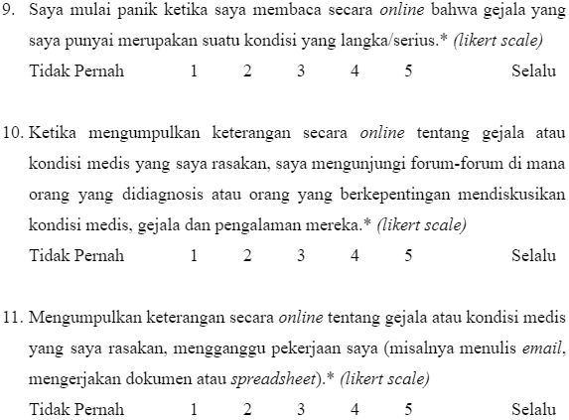
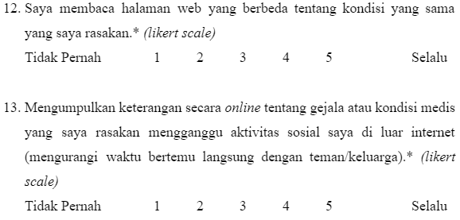
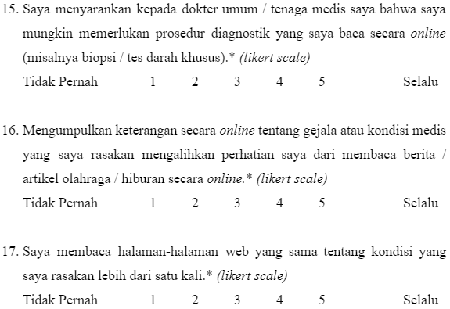
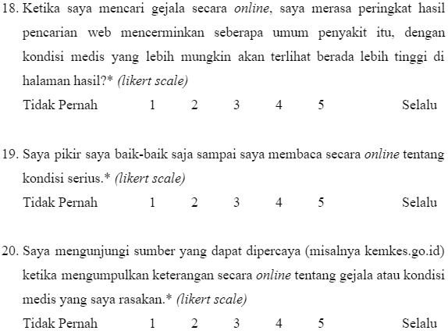
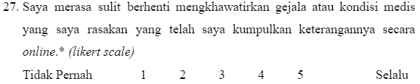
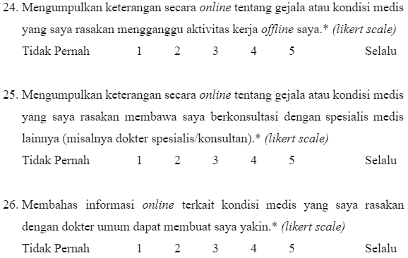
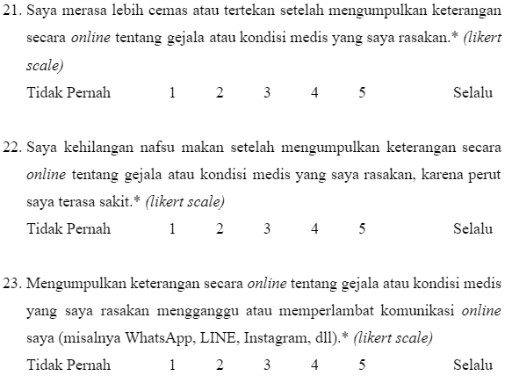
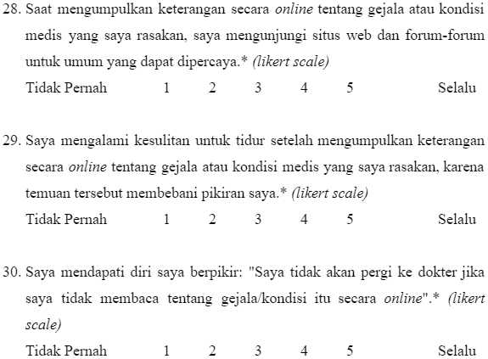
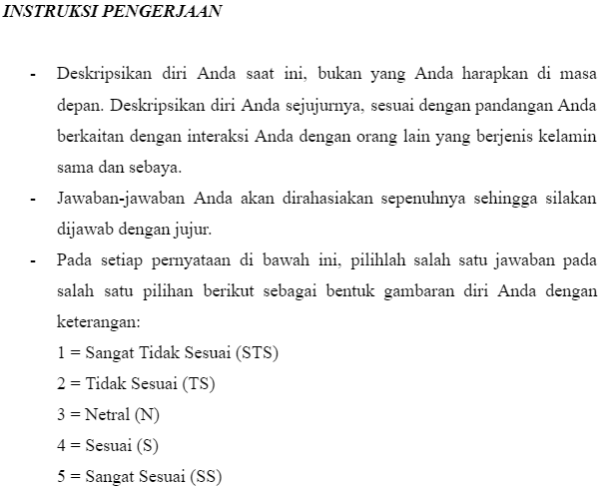
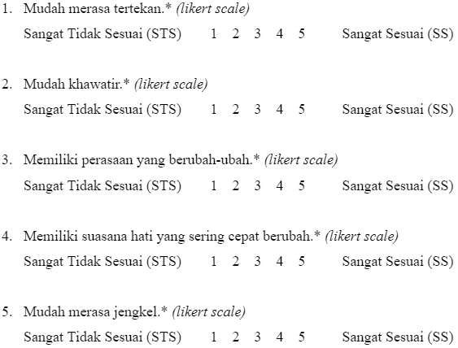
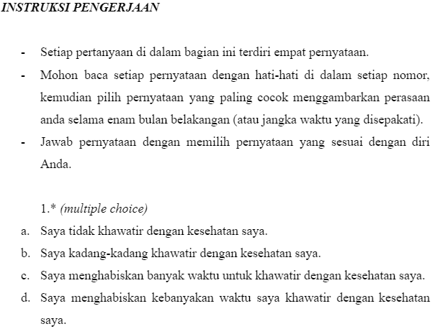
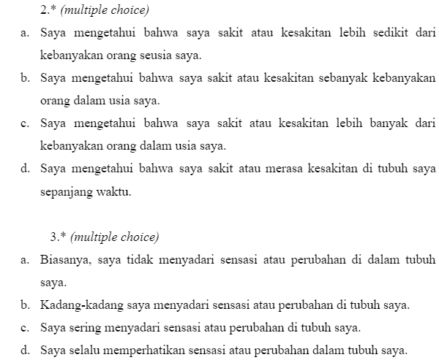
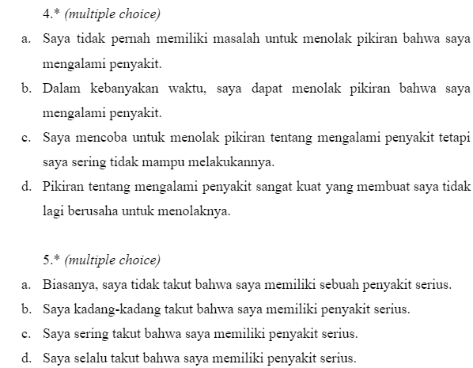
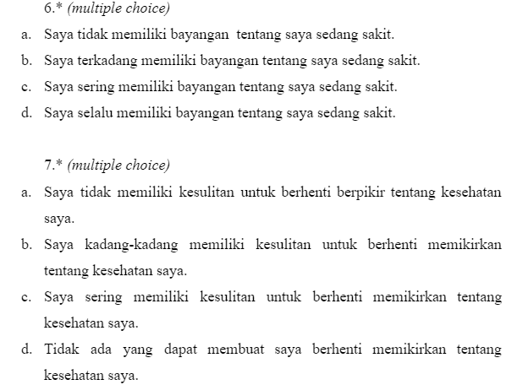
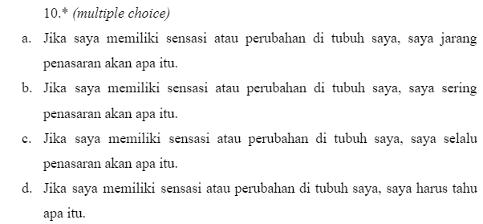
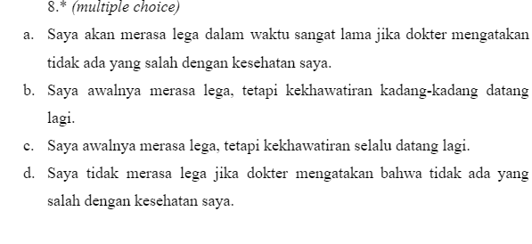
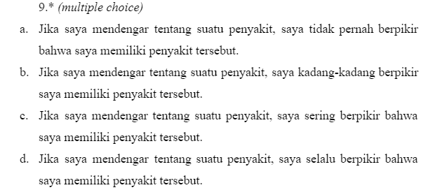
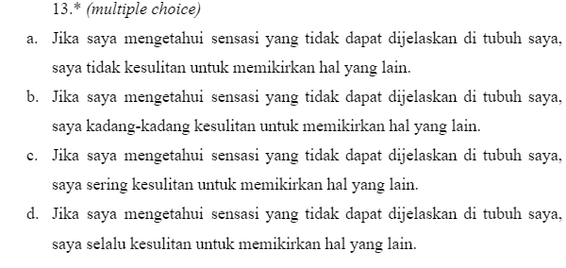
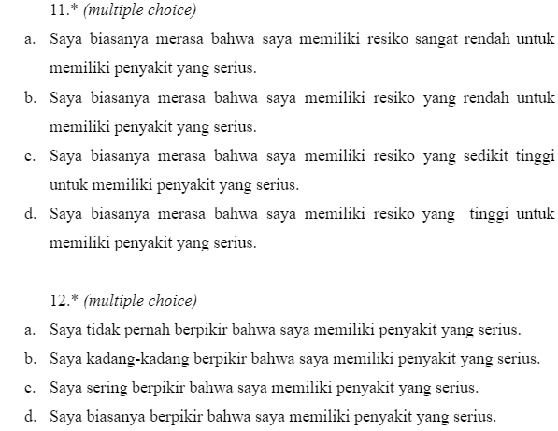
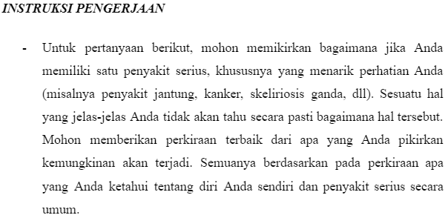
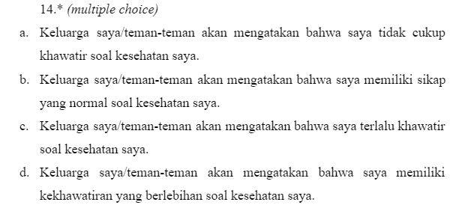
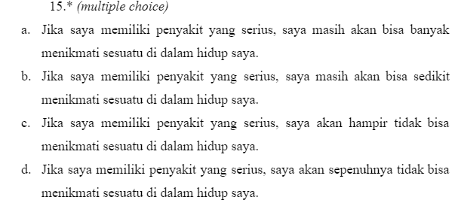
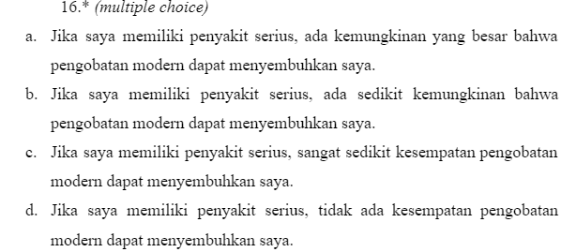
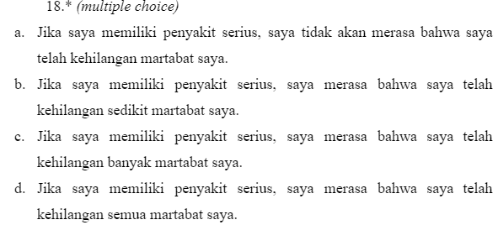
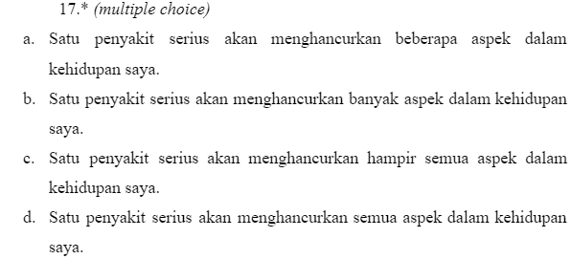

LAMPIRAN B - HASIL OUTPUT PENGOLAHAN DATA
- Reliabilitas dan Validitas Alat Ukur Try Out
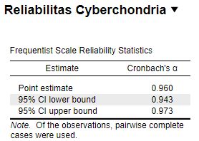
- Reliabilitas Total Cyberchondria Severity Scale (CSS)
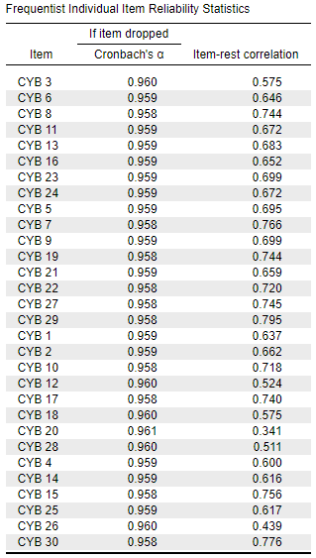
- Validitas Total Cyberchondria Severity Scale (CSS)

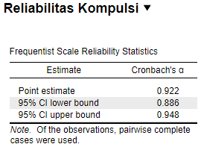
- Reliabilitas CSS Dimensi Kompulsi
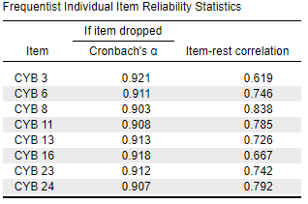
- Validitas CSS Dimensi Kompulsi
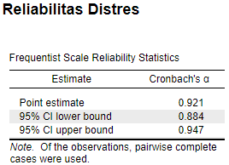
- Reliabilitas CSS Dimensi Distres

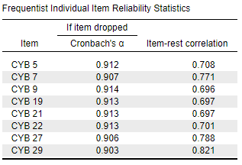
- Validitas CSS Dimensi Distres
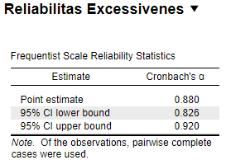
- Reliabilitas CSS Dimensi Akses Berlebih
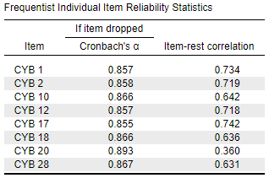
- Validitas CSS Dimensi Akses Berlebih

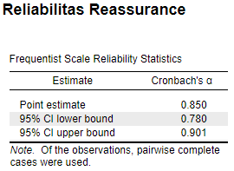
- Reliabilitas CSS Dimensi Kebutuhan untuk Diyakinkan (reassurance)
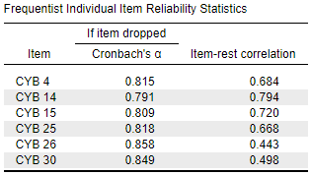
- Validitas CSS Dimensi Kebutuhan untuk Diyakinkan (reassurance)
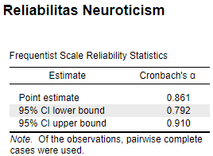
- Reliabilitas IPIP-BFM-25 sub skala Emotional Stability (Neuroticism)
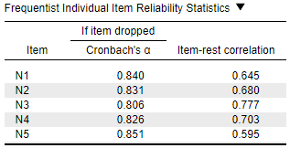
- Validitas IPIP-BFM-25 sub skala Emotional Stability
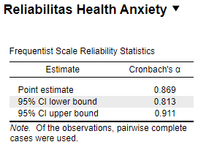
- Reliabilitas Total Short Health Anxiety Inventory (SHAI)
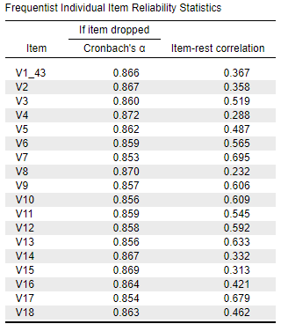
- Validitas Total Short Health Anxiety Inventory (SHAI)
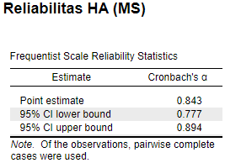
- Reliabilitas SHAI Dimensi the Feared Likelihood of Becoming Ill
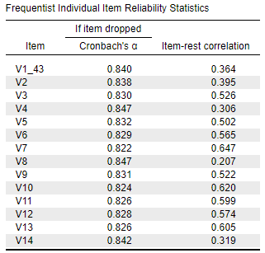
- Validitas SHAI Dimensi the Feared Likelihood of Becoming Ill
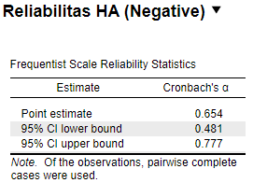
- Reliabilitas SHAI Dimensi the Feared Negative Consequences of Becoming Ill
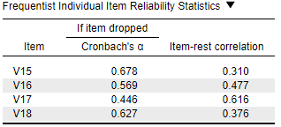
- Validitas SHAI Dimensi the Feared Negative Consequences of Becoming Ill

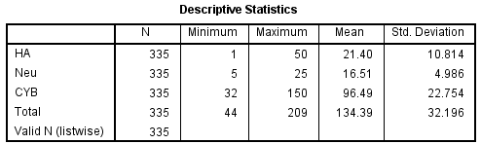
- Analisis Deskriptif

- Reliabilitas dan Validitas Alat Ukur Data Field
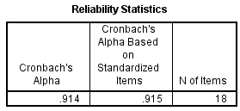
- Reliabilitas dan Validitas Total Short Health Anxiety Inventory (SHAI)
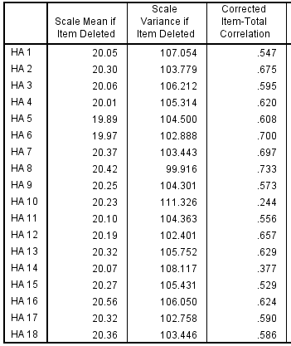

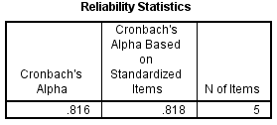
- Reliabilitas dan Validitas IPIP-BFM-25 sub skala Emotional Stability
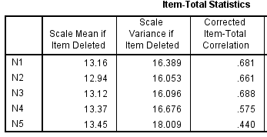
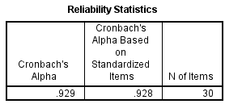
- Reliabilitas dan Validitas Total Cyberchondria Severity Scale (CSS)
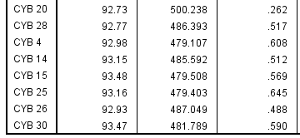
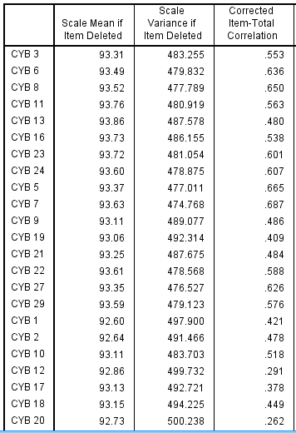
- Uji Asumsi Klasik: Normalitas Residual
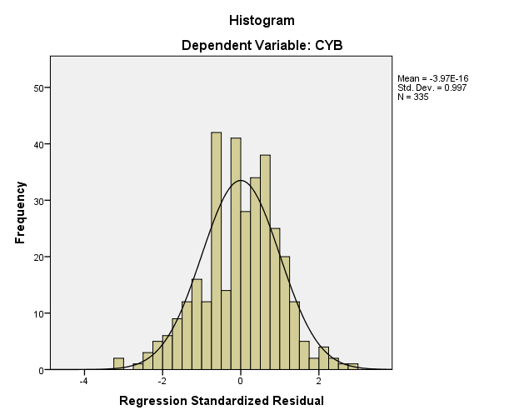
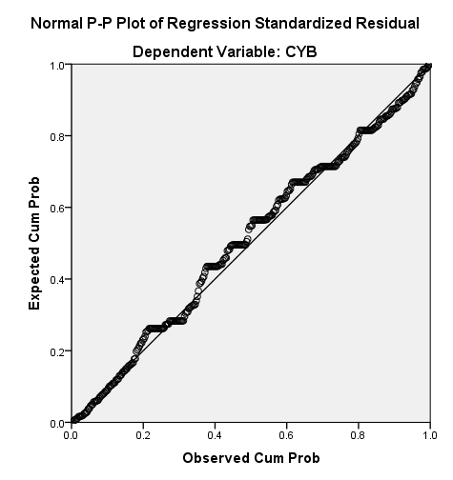
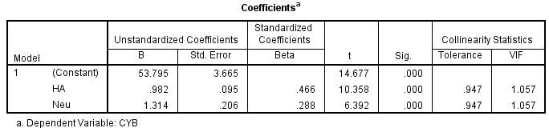
- Uji Asumsi Klasik: Multikolinearitas

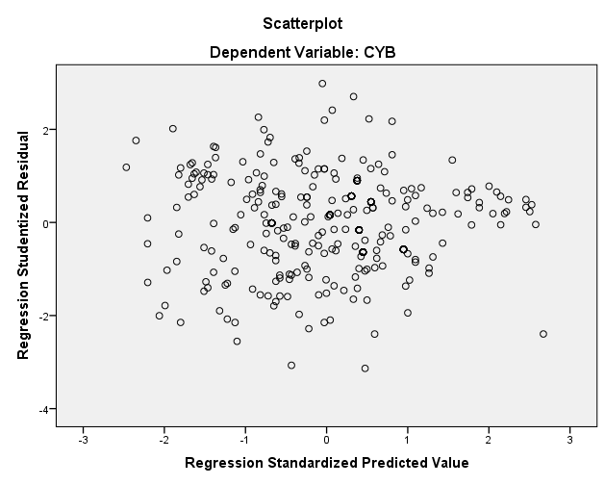
- Uji Asumsi Klasik: Heteroskedastisitas

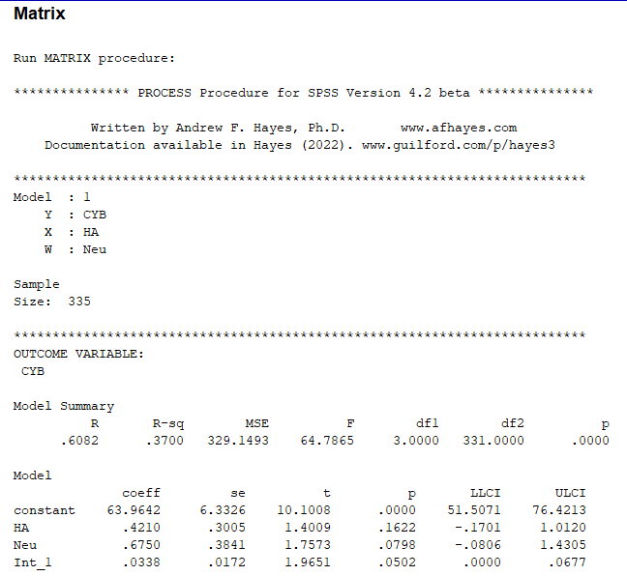
- Uji Moderasi
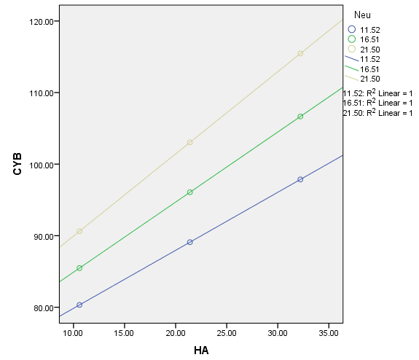
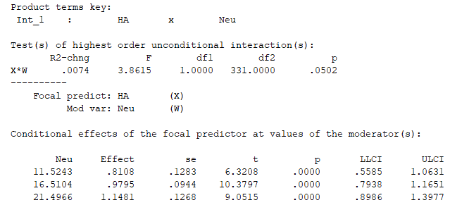
Graph
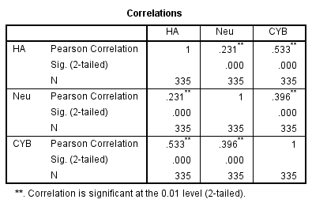
- Uji Korelasi Health Anxiety, Neuroticism, dan Cyberchondria

- Uji Beda Berdasarkan Jenis Kelamin
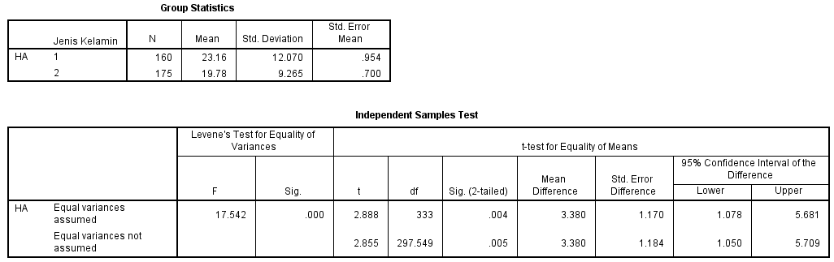
- Uji Beda Health Anxiety Laki-Laki dan Perempuan

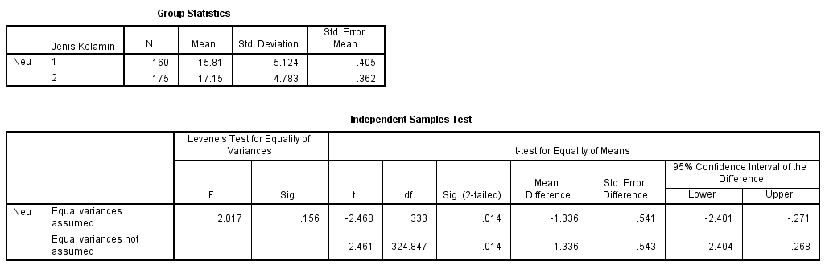
- Uji Beda Neuroticism Laki-Laki dan Perempuan

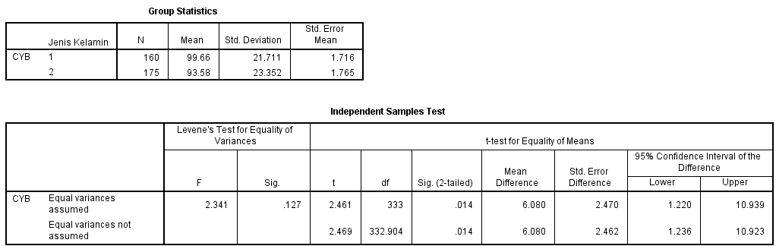
- Uji Beda Cyberchondria Laki-Laki dan Perempuan

LAMPIRAN C - E-MAIL KORESPONDENSI ALAT UKUR

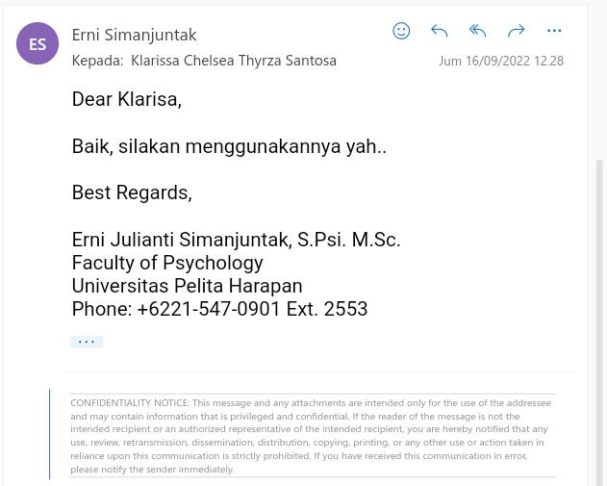
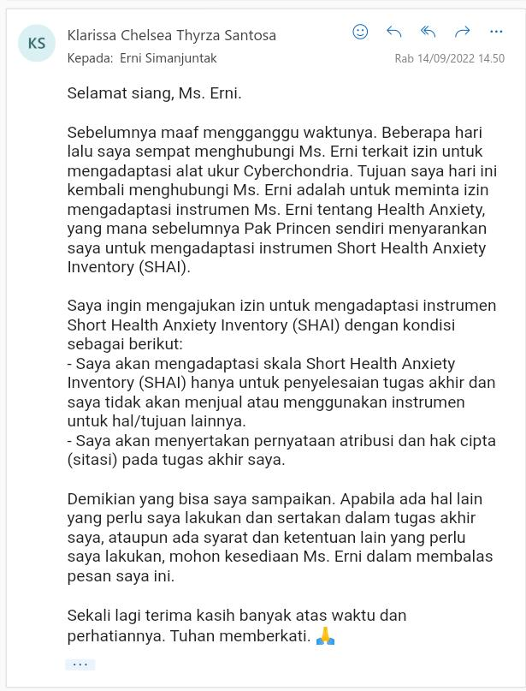
Gambar 1 Korespondensi Izin Adaptasi Alat Ukur Short Health Anxiety Inventory (SHAI)

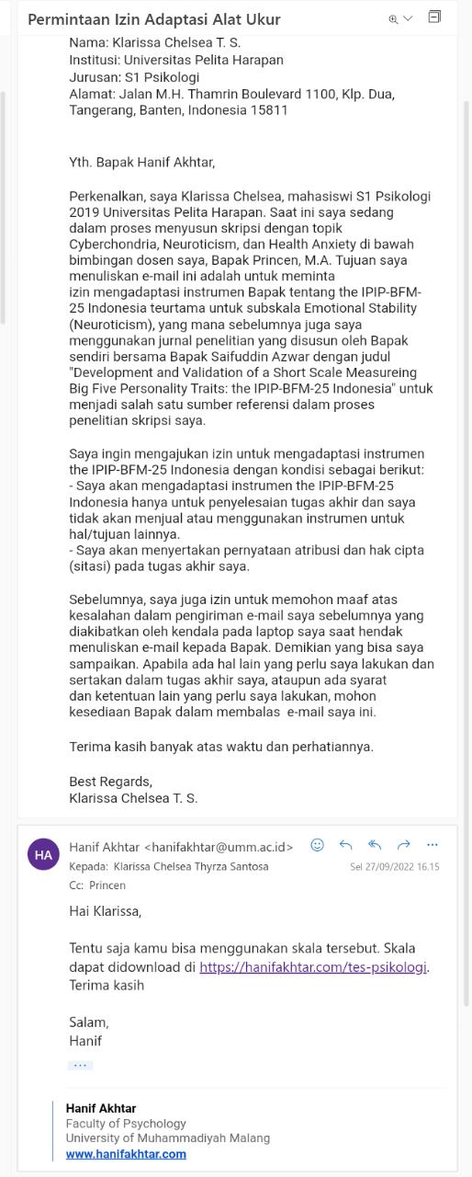
Gambar 2 Korespondensi Izin Adaptasi Alat Ukur IPIP-BFM 25

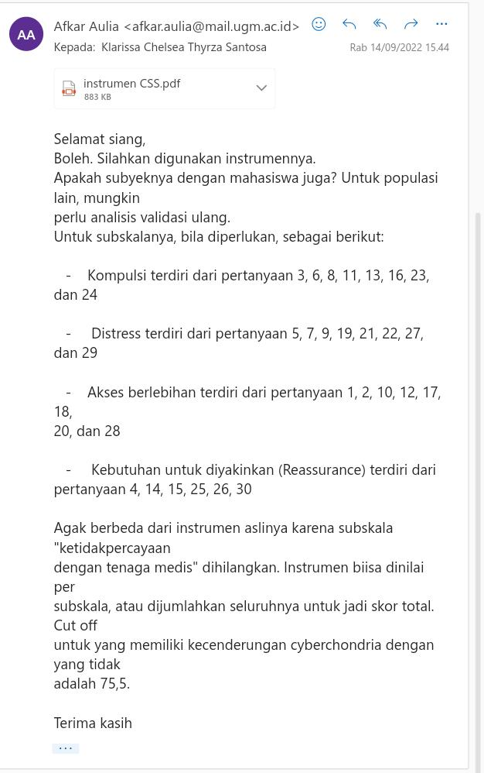
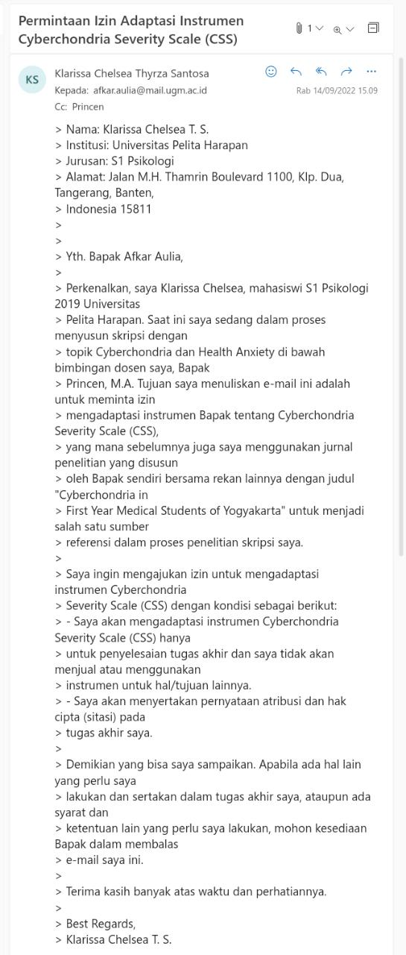
Gambar 3 Korespondensi Izin Adaptasi Alat Ukur Cyberchondria Severity Scale (CSS)

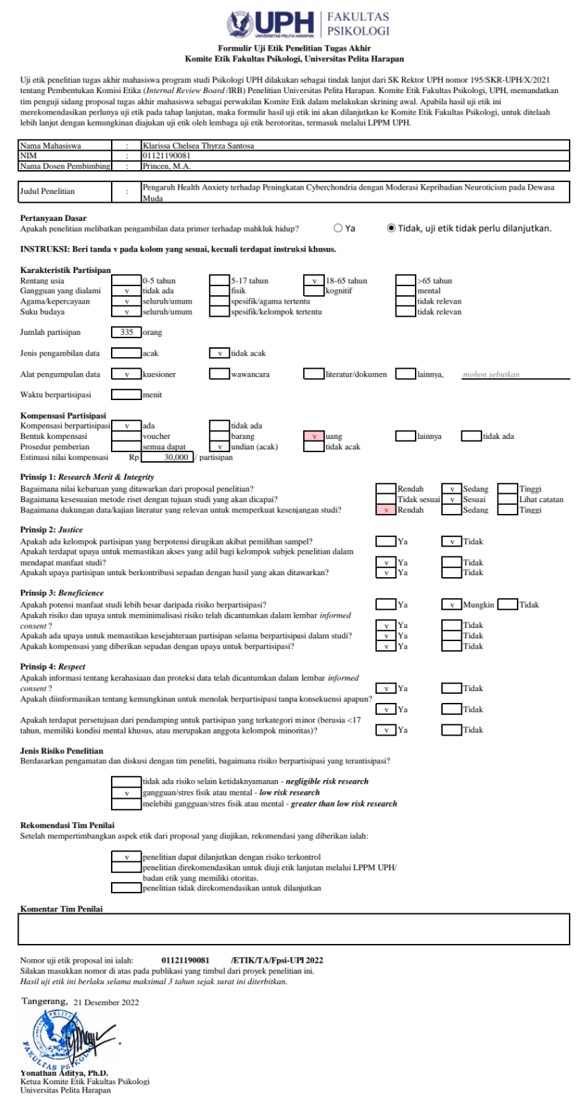
LAMPIRAN D - UJI ETIK PENELITIAN

Gambar 4 Uji Etik Penelitian Tugas Akhir

