ANALYSIS OF OVO APPLICATION SENTIMENT USING LEXICON BASED METHOD AND K-NEAREST NEIGHBOR

¹Sandra Dwi Widiyaningsih,²Atit Pertiwi
^{1,2}Faculty of Computer Science and Information Technology, Universitas Gunadarma
Jl. Margonda Raya No. 100, Depok 16424, West Java
¹sandradw.sd@gmail.com, ²atit@staff.gunadarma.ac.id

Abstract

Money that has a function as a measuring tool, medium of exchange, and payment tools is transformed according to the development of the digital era with the issuance of electronic money. OVO is an electronic money application in Indonesia. The public can provide a review of the service OVO application on the google play store. Further, the company can see how the responses from the user regarding the product as an evaluation of application performance so that improvements can be made. This requires a system for analyzing reviews by applying sentiment analysis use the R language. The aim of this study is to analyze OVO application sentiment using lexicon based method and k-nearest neighbor. The initial stage of sentiment analysis is pre-processing which consists of case folding, cleansing, stop word, slang-word, and stemming. The data classification process is divided into two classes, namely positive and negative classes using the lexicon-based method, the data that has been carried out is then divided into training data and test data that will be used in the training and testing process using the Confusion Matrix. The results of the accuracy of the system using the k-nearest neighbor algorithm of 93.84%. with a positive preposition of 96,29%, negative preposition of 68,75%, positive recall of 96,18%, negative recall of 73,33% and error system of 6,16%.

Keywords : Confusion Matrix, K-Nearest Neighbor, Lexicon Based, Sentiment
Analysis

This paper is a revised and expanded version of a paper entitled Analysis of OVO Application Sentiment Using Lexicon Based Method and K-Nearest Neighbor presented at UG Economic Faculty International Conference October 31st , 2019, Bekasi, West Java, Indonesia.

INTRODUCTION

At present, the world is entering the era of the industrial revolution 4.0 or the fourth world industrial revolution where information technology has become the basis in human life. Everything becomes infinite, because it is influenced by the development of the internet and digital technology. Money that has a function as a medium of exchange and payment instrument is transformed according to the development of the digital era with the issuance of electronic money. One example of electronic money applications in Indonesia is OVO. OVO application on the Google Play Store, is a digital content service owned by Google. In the Google Play Store, there is a review feature from users that allows users to provide reviews. There are a large number of reviews from users, in order to help analyze public opinion on the reviews given on the OVO application. This review provided information for consideration using OVO and to be able to know the response of the public. From this public response, OVO could make improvement of services and the tools to analyze the reviews by applying sentiment analysis. Sentiment analysis is computational research of opinions, sentiments, and emotions expressed textually. The use of sentiment analysis is generally used to analyze a product in improving product quality going forward (Gunawan, Fauzi, Adikara, 2017). In conducting sentiment analysis, there are several methods, one of which is the K-Nearest Neighbor method. There are several advantages of the K-Nearest Neighbor method, namely the K-Nearest Neighbor classification algorithm that is proven to achieve good accuracy results and is by the calculations applied in an application (Sani, Zeniarja, & Luthfiarta, 2016). The K-Nearest Neighbor algorithm is very commonly used to categorize texts (Samuel, Delima, & Rachmat, 2014). Dey, Chakraborty, Biswas, Bose and Tiwari (2016) discusses two supervised machine learning algorithms: K-Nearest Neighbour(K-NN) and Naïve Bayes’ and compares their overall accuracy, precisions as well as recall values. It was seen that in case of movie reviews Naïve Bayes’ gave far better results than K-NN but for hotel reviews these algorithms gave lesser, almost same accuracies.
Several previous studies on sentiment classification were conducted by (Nurjanah, Perdana, & Fauzi, 2017). This study uses the k-nearest neighbor method and weighting the number of retweets to classify comments. However, this research has a shortage in terms of classifying comments so that it reduces the level of accuracy. Further research on sentiment analysis was conducted by (Ernawati & Wati 2018). This study uses the k-nearest neighbor method as a classification of comments on web travel accounts and retrieves data that has been grouped on the web. the results of this study showed an accuracy of 87%. Subsequent research was conducted by (Kusumawati & Pamungkas, 2017). This study uses the Lexicon Based method to see people's perceptions of rising cigarette prices on Twitter social media, but in this study, no sentence normalization was conducted on non-standard word problems.
Based on the description above, the aim of the study to analysis an OVO application sentiment using the lexicon-based method and k-nearest neighbor. The method used in this study is the Waterfall system development life cycle method.

LITERATURE REVIEW

Sentiment Analysis
Sentiment analysis or opinion mining is the process of examining opinions on individual views to get sentiment information contained in an opinion sentence. Sentiment analysis is done to see the opinion or tendency of opinion on a problem or object by someone, whether they have negative or positive opinion. (Rozi, Pramono, Dahlan, 2013) This value can be used as a parameter in decision making (Haryanto, Muflikhah, Fauzi, 2018).

Lexicon Based
Lexicon Based is a classification process to determine each word according to the lexicon dictionary. So that in a sentence the number of positive and negative values ​​in each of the constituent words is known (Kusumawati & Pamungkas 2017).

State of The Art of The Research
This research was conducted by studying the research carried out before, by having sentiment analysis related, the lexicon based method, and the k-nearest neighbor method. The following is a previous study relating to this research can be seen in Table 1.

Table 1. Related Research
No | Name | Year | Tittle | Deficiency
1 | Nurfalah, Adiwijaya, and Suryani | 2017 | Analysis of Indonesian Language Sentiments with the Lexicon-Based Approach to Social Media | Accuracy of 66% has not reached more than 90% of unstructured sentences in accordance with standard rules of grammar
2 | Kusumawati, and Pamungkas | 2017 | Sentiment Analysis Using Lexicon Based to See Public Perceptions of Cigarette Price Increase on Twitter Social Media | Accuracy of 81% has not reached more than 90%. No sentence normalization is carried out on the problem of nonstandard words
3 | Nurjanah, Perdana, Fauzi | 2017 | Sentiment Analysis of Television Shows Based on Public Opinion on Twitter Social Media using the K-Nearest Neighbor Method and Weighting the Number of Retweets | Accuracy of 83.33% has not reached more than 90%.

RESEARCH METHOD

The method used in the preparation of this study uses the Waterfall method. The stages are as follows: (1)Analysis, this stage is the process of analyzing system requirements and users as well as analyzing OVO application review data and developing system concepts to be made. (2)Design, at the design stage, system design is carried out, designing the interface as needed, making the code into an application that will be made with the help of navigation structures in programming. (3)Implementation, this stage is the process of implementing a system that has been created, as well as the system support plan. (4)System Testing, testing the sentiment analysis application system using the Confusion Matrix method to determine the performance of the data classification results.
As in Figure 1, the steps in conducting research on OVO application sentiment analysis using k-nearest neighbor and lexicon-based methods consist of (1) problem analysis; (2) system analysis; (3) data source analysis; (4) pre-processing review data; (5) initial classification of sentiments using the Lexicon Based method; (6) classifying data test using the K-Nearest Neighbor method; (7) the calculation of accuracy using a confusion matrix, and (8) visualized in the form of pie charts and word cloud.

Problem Analysis
User reviews of the application can provide information to the public and the application company to find out the quality and reaction of users in terms of services, features, from the application. The application chosen as the object of research is the OVO application. With the reviews from users, the OVO can find out the user's reaction from various aspects, but the applicable company and the users have limited time to dig up the information behind the user reviews. For this reason, we need a system that can process OVO application user review data using sentiment analysis.

Problem Analysis
System Analysis
Source Analysis
Start
Reviews Data
Classification using the K-Nearest Neighbor method
Classification using the Lexicon Based method
Pre-Processing Data
Classification results in the form of pie chart and Wordcloud
Calculation of accuracy using a Confusion matrix
End
Figure 1. Flowchart of Sentiment Analysis

System Analysis
System analysis is carried out to identify existing problems and the needs needed to create a new and better system, system analysis also aims to analyze how the system works, processes carried out from input to output.

Source Analysis
Data from this study were obtained from the OVO application page on the Google Play Store site. Data obtained in the form of OVO application user reviews taken from May 25, 2019 to May 30, 2019 were 1000 reviews.

RESULTS AND DISCUSSION

In this stage, the steps in the system will be described and present the results of the steps that have been done previously in conducting sentiment analysis of OVO using the lexicon-based method and k-nearest neighbor.

Pre-processing

OVO application review data taken from the Google Play Store still has an unstructured sentence form and there is still a lot of noise so that the pre-processing stage is the stage of the cleaning process. At this stage several packages are needed that must be installed and run on RStudio.
The steps of pre-processing seen in Figure 2 are as follow: (1)Change in Capitalization (Case folding), at this stage the capital letters are changed to lowercase letters in the review data. Example letter A is changed to a. The process of folding case review data is carried out simultaneously on review data in one file. (2)Removing Characters and Numbers (Cleansing), data review that has been carried out the process of changing the capitalization, will then be carried out the process of removing characters and numbers, delimiter-delimiter such as punctuation and symbols in the document such as signs (,), $, *, @,!,?, / And so on. The data cleansing review process is carried out simultaneously on review data in one file. (3)Eliminating Unnecessary Words (Stop words), review data that have been done in the process of changing the capitalization, omitting characters and numbers will then be carried out the process of removing unnecessary words if there are words that are considered to have no meaning and are not related to adjectives related to sentiment will be eliminated. (4)Change in Slang word (Spelling normalization), data review that has been carried out the process of changing the capitalization, eliminating characters and numbers, eliminating unnecessary words will then be carried out the process of changing slang word, this stage is done to eliminate the use of slang words or words that are not standard or deemed nonstandard. (5) Transforming Basic Words (Stemming), the stemming process is managing the results of the filtering words into basic words. At this stage, each review data will be checked. This stage is done after the Slang word change.

Start
Reviews Data
Change in Capitalization (Case Folding)

Removing Characters and Numbers (Cleansing)

Eliminating Unnecessary Words (Stopwords)

Change in Slang Word (Spelling normalization)

Transforming Basic Words (Stemming)

Results of
Pre-Processing Data
End
Figure 2. Pre-Processing Flow Diagram

Lexicon Based Classification
The classification using the lexicon-based method is a classification of the sentiment of review data that has been cleaned at the pre-processing stage. This classification is matched with words contained in the negative-positive dictionary according to Ding, Liu and Yu (2008). If the review data has a greater number of positive words then classified positive sentiment, but if the review data has a greater negative word then the negative sentiment is classified in this study to determine a sentence has positive or negative sentiment by counting the number of positive or negative words with use lexicon-based. And to determine positive or negative words in a sentence is determined based on a dictionary of positive and negative words according to Ding, Liu & Yu (2008). Table 2 shows some examples of positive and negative sentiment reviews
In the first review data on the word “baik moga manfaat guna” on the word “baik” and “manfaat” is a positive sentiment, then the score for positive 2 and the score for negative 0 and the number of scores 2. In the second review data on the word “susah login aplikasi update tolong” the word “susah” is a negative sentiment, then the score for positive 0 and the score for negative 1 and the total score of -1.
If the number of negative scores is classified as negative, and if the total score of 0 is classified as neutral. And at this writing only use a positive and negative sentiment. Then sentences that do not have sentiment or neutral will be deleted in the database so that with a total of 1000 review sentences obtained 732 review sentences that have positive and negative sentiment.

K-Nearest Neighbor Classification
At this stage, the classification of test data is carried out whether included in the positive or negative sentiment. This stage is done by the k-nearest neighbor method. The stages are carried out in three stages, namely learning, testing and result in sentiment. The following are the stages of classification using the k-nearest neighbor method.

Table 2. Lexicon Based Classifications
Review | Positive | Negative | Score | Sentiment Class
baik moga manfaat guna | 2 | 0 | 2 | Positive
susah login aplikasi update tolong | 0 | 1 | -1 | Negative

(1)Definition the Dataset, in this study, the review data used are those that have been carried out pre-processing cleaning stage and have been classified by the lexicon-based method. (2)Making dtm, at this stage count the number of vocabulary words in the dataset. Before doing dtm, the definition is done by reading data from a dataset using the corpus function. (3)Training Data, it is data that is used as training data for learning systems, training data is taken from data that has passed the pre-processing process. The proportion of training data used in this study was 80% randomly. 586 reviews become training data. (4)Test Data, test data is data used as system test data. Test data is taken from data that has passed the pre-processing process. The proportion of test data used in this study is the rest of the data which is not training data, which is 20%. 146 reviews become test data

K-Nearest Neighbor Calculations
The following is an example of calculating K-nearest neighbor. The first thing to do is choosing some training data that has been carried out in the preprocessing stage.
Table 3 is the set of training data on the sample data review taken as many as 4 review data.
Table 4 shows test data on the review data sample. whose sentiment is unknown and sentiment will be sought.
Table 5 shows document Data Matrix Term in training data samples and test data. If a word contains the word that is defined, then given a value of 1 if not then given a value of 0. Next will be calculated using the cosine similarity formula as follows:

Cos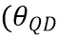) = 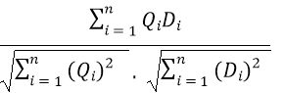 (1)

Table 3. Training Data Sets
No | Review Data | Sentiment
1 | sulit masuk aplikasi | Negative
2 | transfer bank gagal | Negative
3 | transaksi mudah praktis | Positive
4 | bayar mudah | Positive

Table 4. Test Data
No | Test Data | Sentiment
X | aplikasi baik mudah transaksi | ?

Table 5. Example of DTM
Term | difficult | enter | application | good | easy | transaction
1 | 1 | 1 | 1 | 0 | 0 | 0
X | 0 | 0 | 1 | 1 | 1 | 1
Term | transfer | bank | fail | application | good | easy | transaction
2 | 1 | 1 | 1 | 0 | 0 | 0 | 0
X | 0 | 0 | 0 | 1 | 1 | 1 | 1
Term | transaction | easy | practical | application | good
3 | 1 | 1 | 1 | 0 | 0
X | 0 | 1 | 0 | 1 | 1
Term | pay | easy | application | good | transaction
4 | 1 | 1 | 0 | 0 | 0
X | 0 | 1 | 1 | 1 | 1

Cos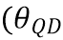) = Similarity of Q to document D
Q = Test Data
D = Training Data
n = Number of Data

Cosinus Similarity Data 1 and X
Cos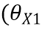) = 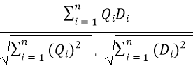 = 0, 289

Cosinus Similarity Data 2 and X
Cos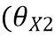) = = 0

Cosinus Similarity Data 3 and X
Cos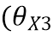) = 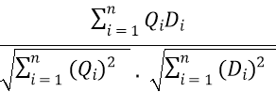 =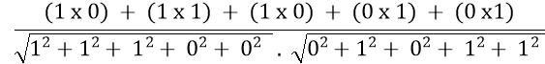 = 0,333

Cosinus Similarity Data 4 and X
Cos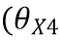) = =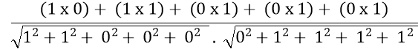 = 0,354

From the above calculation, if the value of k = 1, the largest distance is in the data 4 positive sentiment, then the test data x is categorized as positive sentiment

Classification Result
By using the k-nearest neighbor method, in this study 146 test data or 20% were taken randomly by the system from the lexicon-based sentiment dataset. The results of the classification using the lexicon-based method can be seen in Figure 3.
The results of the test data above can be seen that there are 23 reviews classified as negative sentiment and 123 reviews classified as the positive sentiment. And for the results of sentiment classification using k-nearest neighbor can be seen in Figure 4.
The results of the test data above can be seen that there are 20 reviews classified as negative sentiment and 126 reviews classified as positive sentiment.

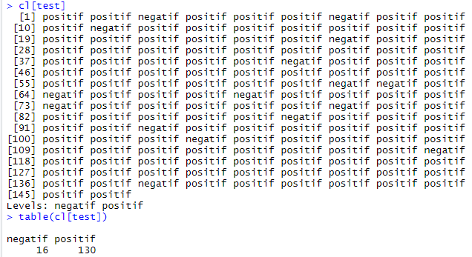
Figure 3. Results of Lexicon Based Test Data

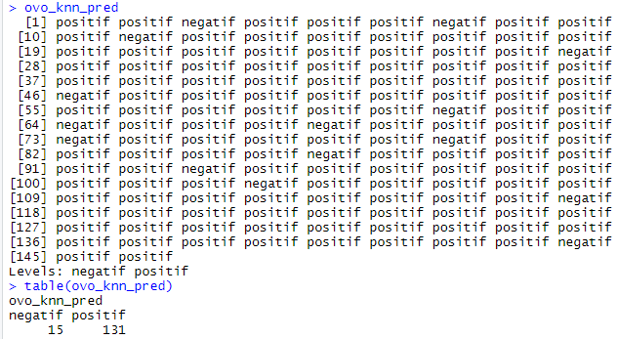
Figure 4. K-Nearest Neighbor Test Data Results

Confusion Matrix Testing
This test is conducted to determine the accuracy of sentiment classification data reviews using the lexicon-based method with review data sentiment classification using k-nearest neighbor. Testing for accuracy is done using a confusion matrix. The test is carried out using 146 test data that is labeled by the system. The table of confusion matrix can be seen below
In Table 6. confusion matrix that the comparison of predicted and actual sentiment from 146 data reviews the number of True Positive is 126 data, False Positive is 4 data, False Negative is 5 data and True Negative is 11 data
After doing the accuracy, the calculation of the value of accuracy, system error, precision, recall, and specificity are calculated.

- Accuracy
Accuracy = (TP + TN) / (TP + TN + FP + FN)
Accuracy = (126 + 11) / (126 + 11 + 4 + 5)
Accuracy = 137 / 146 = 0,9384 * 100% = 93,83%

- System Error
System Error = 1 – Accuracy
System Error = 1 – 0,9384 = 0,0616 * 100% = 6,16%

Table 6. Confusion Matrix Results
The Amount of Data Test : 146 | Positive Sentiment Analysis Result | Negative Sentiment Analysis Result
Positive Original Sentiment | (TP) True Positive : 126 | (FP) False Positive : 4
Negative Original Sentiment | (FN) False Negative : 5 | (TN) True Negative : 11
- Precision
Positive Precision = (TP)/ (TP+FP)
Positive Precision = (126)/ (126 + 4)
Positive Precision = 126 / 130 = 0,9692 * 100% = 96,92%
Negative Precision = (TN)/(TN+FN)
Negative Precision = (11) / (11 + 5)
Negative Precision = 11 / 16 = 0,6875 * 100% = 68,75%

- Recall / Sensitivity
Positive Recall = (TP)/(TP+FN)
Positive Recall = (126) / (126 + 5)
Positive Recall = 126 / 130 = 0,9618 * 100% = 96,18%
Negative Recall = (TN)/(TN+FP)
Negative Recall = (11) / (11 + 4)
Negative Recall = 11/ 15 = 0,7333 * 100% = 73,33%

The accuracy testing data obtained in table 6. were 146 review test data, there were 123 positive sentiment review data and 23 negative sentiment review data. The results of the classification conducted by the system are 126 review data including positive sentiment and 20 review data including the negative sentiment. Then the correct classification of the test data is 137 data. Based on testing the accuracy of using a confusion matrix from the Ovo application sentiment analysis system using the k-nearest neighbor method of 93.83% with an error of 6.17%, Positive Precision 96.92%, and Negative Precision 68.75%, Positive Recall 96.18 % and Negative Recall 73.33%. Then concluded the accuracy testing using the confusion matrix that K-nearest neighbor method that can be used because of its large level of accuracy.

Data Visualization
At this stage data visualization will be carried out in the form of pie charts, and wordcloud also aims to find out overall topics that are often reviewed by OVO application users. In addition, visualization was carried out on each positive and negative sentiment class and the interrelationship between words.

Pie Chart
Visualization in the form of a pie chart for the whole data can be seen in Figure 5 below:
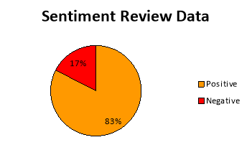
Figure 5. Sentiment Review Data Circle Diagram

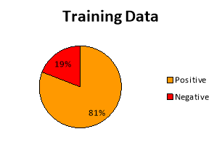
Figure 6. Train Data Circle Diagram

In the overall review classification results can be seen in Figure 5. data totaling 732 sentiment review data with 83% of data are categorized as Positive Sentiments and 17% of Data are categorized as Negative Sentiments, which means people tend to give good opinions on OVO applications, so many users to use OVO applications because the majority of people satisfied with the use of the applications seen from taking people comment data in google play store regarding assessment or responses of OVO applications. Therefore many people download the OVO application.
When will do the test with k-nearest neighbor method, comment data has been taken previously is divided into training data and test data. Training data is data that already exist previously to be used as reference for conduct training data on test data. As in Figure 6, the result of training data classification is 81% are in category of positive sentiment and 19% are in category of negative sentiment. It means many people give a good coment in training data.
Test data is data that will be tested on training data to evaluate performance of the k-nearest neighbor method. As in Figure 7, the result of test data classification is 89% are in category of positive sentiment and 19% are in category of negative sentiment. It means many people give a good comment in test data.
As seen in Figure 8, when testing the test data, the results obtained classification of positive sentiment test data as much as 90% and negative sentiment as much as 10%. It means the k-nearest neighbor method is good in classifying because the results are not much different from the test data, which is only 1% different and the results show that the positive sentiment is greater than the negative which means the community feels the OVO application is good to use. So they download OVO application for make it easy to make payment transactions without the need to carry cash
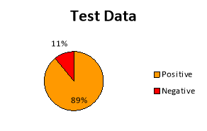
Figure 7. Test Data Circle Diagram

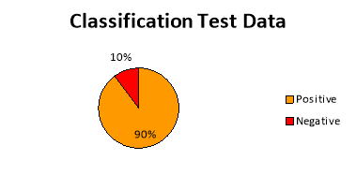
Figure 8. Circle Diagram of Test Results Classification Data

Word-cloud
Visualizations for words that often appear in positive sentiment reviews can be seen in the form of Word-cloud like Figure 9. below
In the picture above can be seen the words that are often used in positive sentiment reviews. The greater the word size on word-cloud, the higher the frequency of the word, users often use the word for reviews with positive ratings.
Visualizations for words that often appear in negative sentiment reviews can be seen in the form of Word-Cloud like Figure 10. below
In the picture above can be seen the words that are often used in negative sentiment reviews. The greater the word size on word-cloud, the higher the frequency of the word, users often use the word for reviews with positive ratings.
Implementation of the User Interface
Implementation of the user interface design that was created in the previous section, can be seen below.
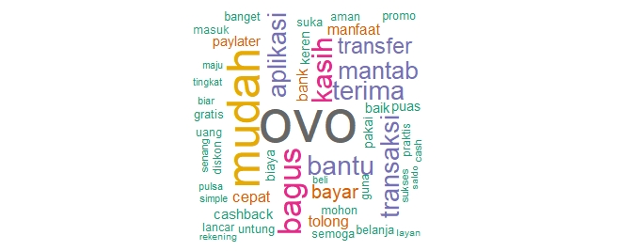
Figure 9. Wordcloud Positive Review
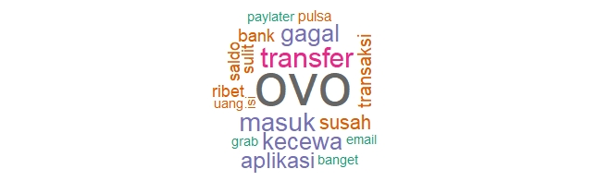
Figure 10. Word-cloud Negative Review
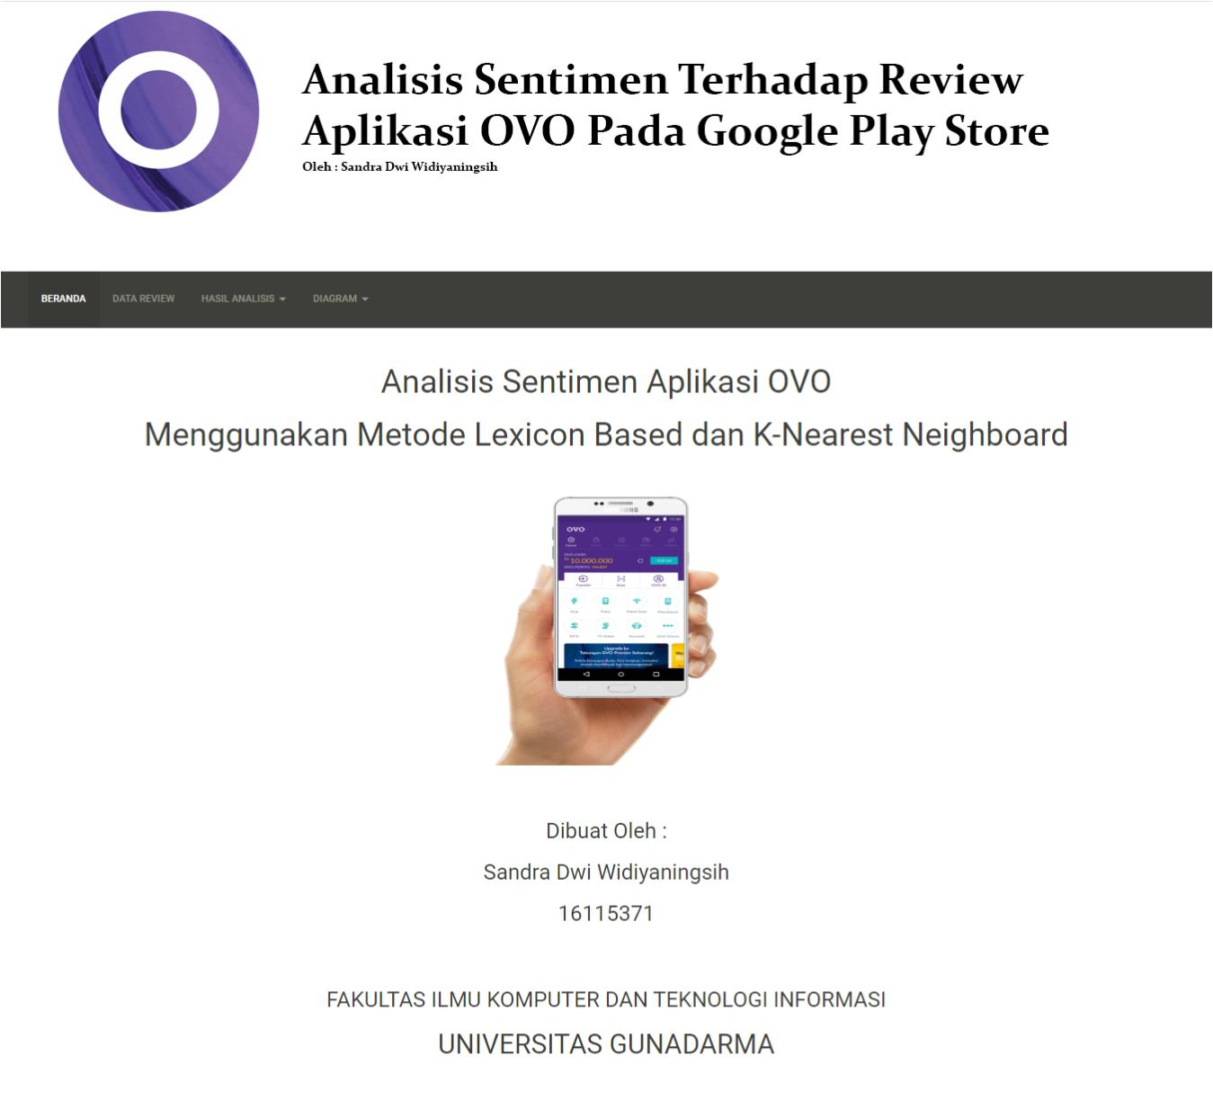
Figure 11. Display Home Page

- Home Page Display
The display of user interface home page can be seen in Figure 11.
- Display Data Review Page
Figure 12 shows the display of data review page.
3. Display Analysis Results Page
The analysis results page is a page that displays the results of the review data that has been pre-processed and carried out the k-nearest neighbor stage.
- Appearance Results Page Views
The assessment results page can be seen in Figure 13.
- Test Results Page Display
The display of result page can be seen in Figure 14.

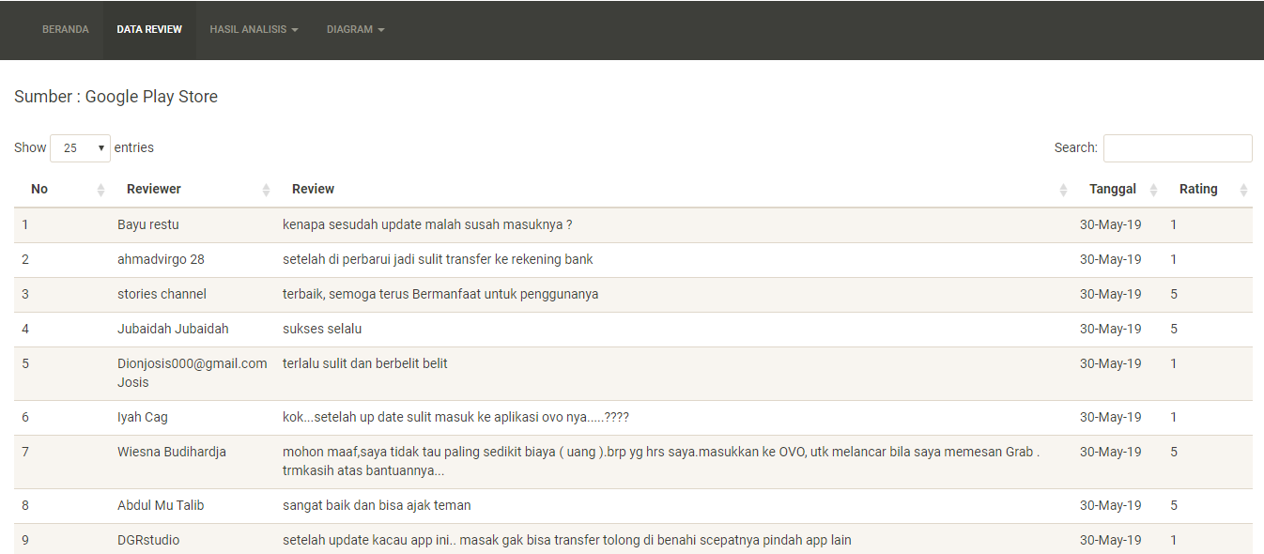
Figure 12. Display Data Review Page

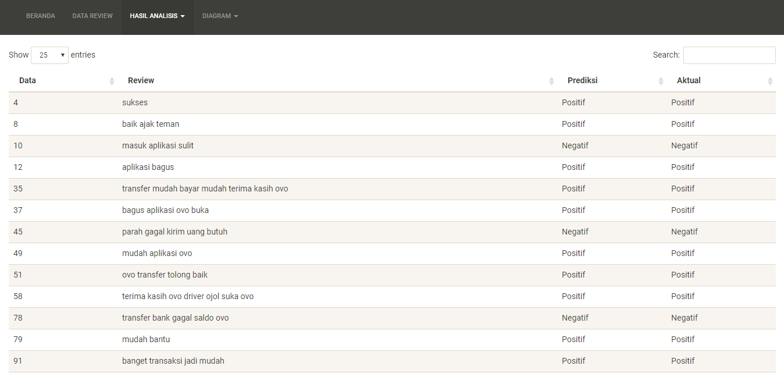
Figure 13. Appears Assessment Results

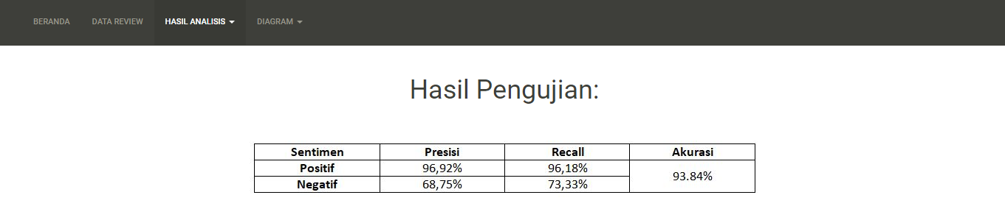
Figure 14. Display of Test Results Page

4. Display Diagram Pages
This page displays the visualization results of a circle diagram, a bar chart, and wordcloud.
- Display of Pie Chart Pages
Figure 15 shows the display of pie charts page.
- Display of Wordcloud Pages
Figure 16 shows the display of wordcloud page.

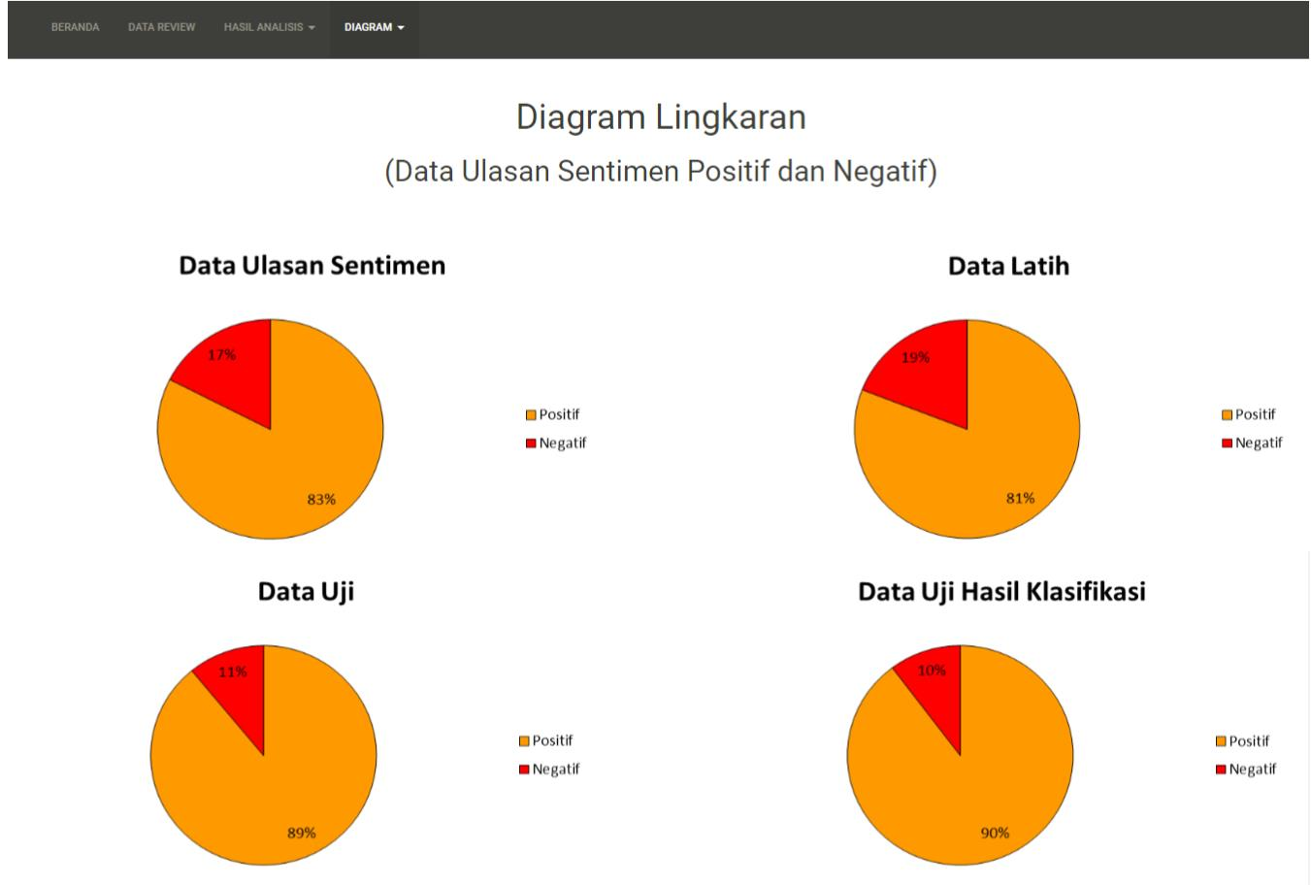
Figure 15. Display of Pie Chart Pages

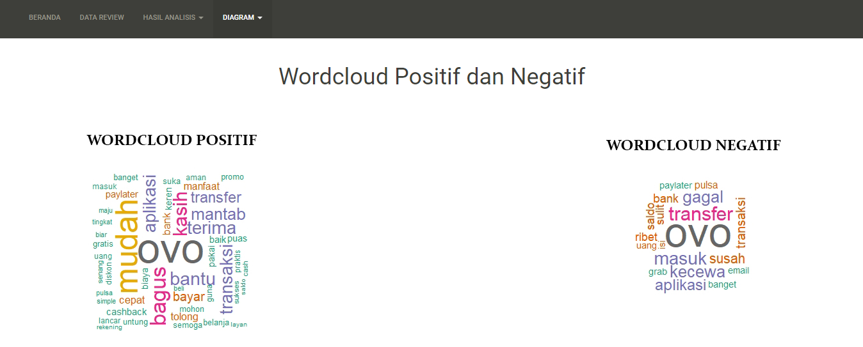
Figure 16. Display of Wordcloud Pages

CONCLUSION AND SUGGESTION

In the OVO application sentiment analysis research obtained the results of classification accuracy from review data using K-Nearest neighbor of 93.83% with positive precision of 96.29%, negative precision of 68.75%, recall of 96.18%, specificity of 73.33% and system errors 6.17%. The results of the classification test data of 131 positive reviews and 15 negative reviews then based on the results of the analysis in this study it can be concluded that the Ovo application tends positive sentiment and the K-Nearest Neighbor method is good in conducting sentiment analysis.
This research is still needed to be developed so that it can use other methods as a comparison of the performance of the K-Nearest Neighbor algorithm to classify OVO application reviews on the Google Play site and can process data dynamically in the sentiment analysis process.

REFERENCES

Dey, L., Chakraborty, S., Biswas, A., Bose, B., & Tiwari, S. (2016). Sentimen analysis of review datasets using Naive Bayes’ and K-NN Classifier. International Journal of Information Engineering and Electronic Business, 8(4), 54-62.
Ding, X., Liu, B., & Yu, P.S. (2008). A holistic lexicon-based approach to opinion mining. Proceedings of the Internasional Conference on Web Search and Web Data Mining, WSDM, California, USA.
Ernawati, S., & Wati., R. (2018). Penerapan algoritma k-nearest neighbors pada Analisis Sentimen Review Agen Travel. Jurnal Ilmu Komputer, 6(1), 82-86. doi : 10.31294/jki.v6i1.3802.g2626.
Gunawan F., Fauzi M.A., & Adikara, P. P. (2017). Analisis sentimen pada ulasan aplikasi mobile menggunakan Naïve Bayes dan normalisasi kata berbasis Levensthein Distance (Studi kasus aplikasi BCA Mobile). Jurnal Pengembangan Teknologi Informasi dan Ilmu Komputer, 1(10), 1082-1088.
Haryanto, D.J, Muflikhah L., & Fauzi, M.A. (2018). Analisis sentimen review barang berbahasa Indonesia dengan metode support vector machine dan query expansion. Jurnal Pengembangan Teknologi Informasi dan Ilmu Komputer, 2(9), 2909–2916.
Kusumawati, I., Pamungkas E.W. (2017). Analisa sentimen menggunakan lexicon based untuk melihat persepsi masyarakat terhadap kenaikan harga rokok pada media sosial twitter (Bachelor’s Tesis). Universitas Muhammadiah Surakarta, Solo, retrieved from http://eprints.ums.ac.id/49476/3/NASKAH%20PUBLIKASI.pdf
Nurfalah A., Adiwijaya, & Suryani A. A. (2017). Analisis sentimen berbahasa Indonesia dengan pendekatan lexicon-based pada media sosial. Jurnal Masyarakat Informatika Indonesia, 2(1), 1-8.
Nurjanah, W.E., Perdana, R.S., & Fauzi, M.A. (2017). Analisis sentimen terhadap tayangan televisi berdasarkan opini masyarakat pada media sosial twitter menggunakan metode k-nearest neighbor dan pembobotan jumlah retweet. Jurnal Pengembangan Teknologi Informasi dan Ilmu Komputer, 1(12), 1750-1757.
Primartha, R. (2018). Belajar machine learning teori dan praktik. Informatika: Bandung
Rozi, I.F., Pramono, S. H., & Dahlan, E.A., (2013). Implementasi Opinion Mining (Analisis Sentimen) untuk Ekstraksi Data Opini Publik pada Perguruan Tinggi. Jurnal EECCIS, 6(1), 37–43.
Samuel, Y., Delima, R., & Rachmat, A. (2014). Implementasi metode k-nearest neighbor dengan decision rule untuk klasifikasi subtopik berita. Jurnal Informatika, 10(1),1- 15.
Sani, R. R., Zeniarja, J., & Lutfhiarta A. (2016). Penerapan algoritma k-nearest neighbor pada information retrieval dalam penentuan topik referensi tugas akhir. Journal of Applied Intelligent System, 1(2), 123-133. doi: 10.33633/jais.v1i2.1189

